Lab 3: Wireshark Lab: DNS

Question 1:

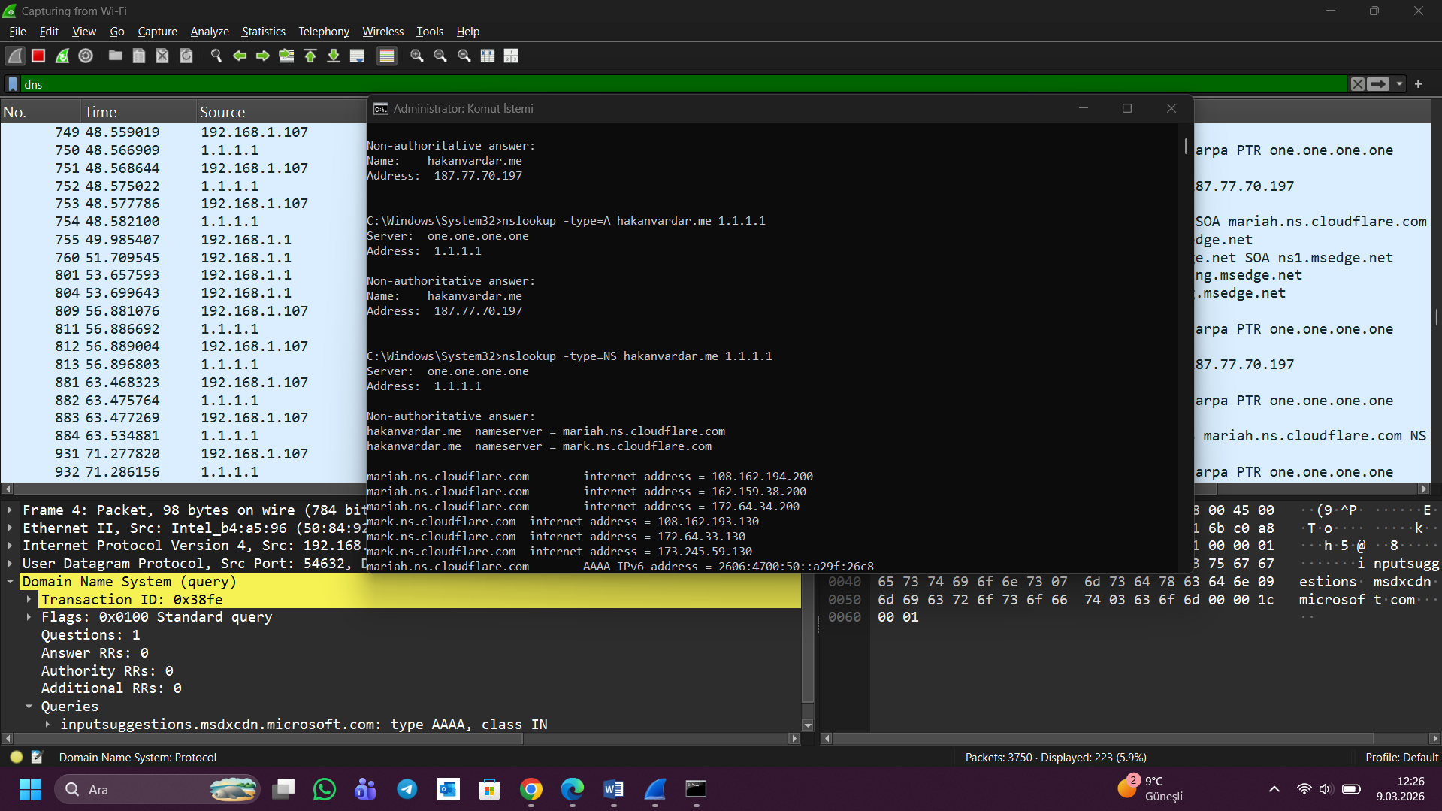

The IPv4 address of the domain "hakanvardar.me" is 187.77.70.197. The IPv4 address of the domain is obtained by using the "nslookup" command and specifying the "A record" from the DNS server. The command is used to send a request to the DNS server and resolve the domain name with the corresponding IPv4 address.

Question 2:

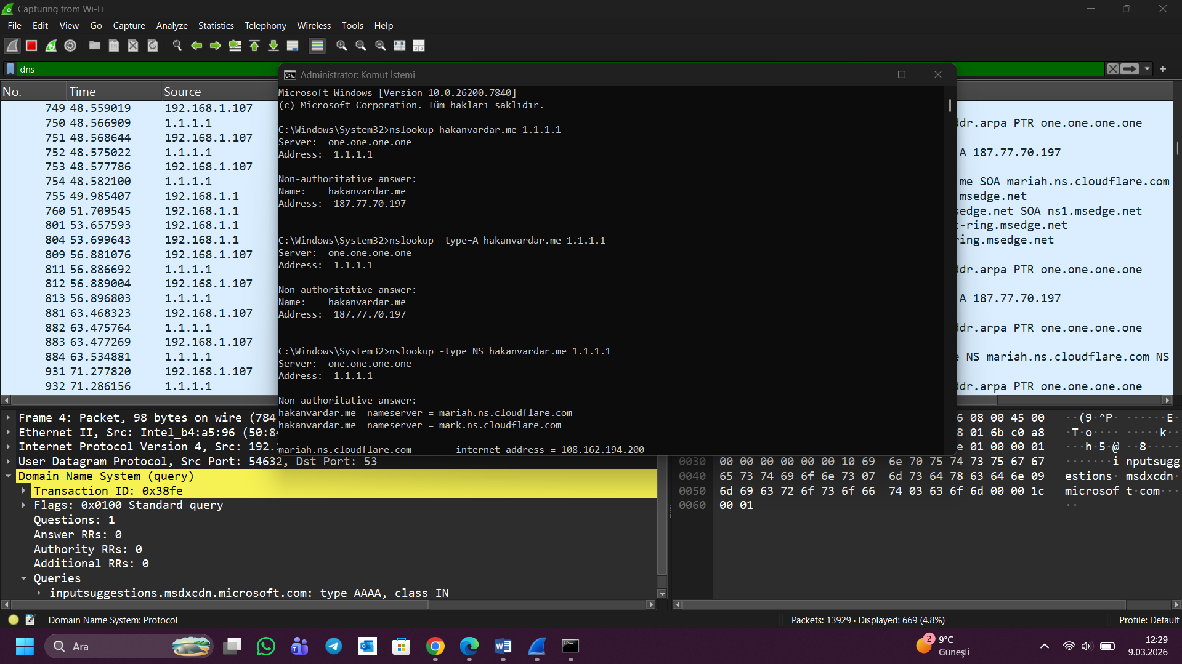

The IP address of the DNS server that provided the response is 1.1.1.1.
This DNS server is Cloudflare Public DNS. This DNS server has responded to the nslookup query by providing the IPv4 address of the domain name ‘hakanvardar.me’.

Question 3:

In the result provided by the nslookup command, it is clear that the answer is not authoritative. This indicates that the answer was not obtained directly from the DNS server but rather from a resolver. An authoritative answer is obtained directly from the DNS server that hosts the domain, whereas a non-authoritative answer is obtained from the DNS cache. Since Cloudflare 1.1.1.1 is a recursive resolver, the response is non-authoritative.

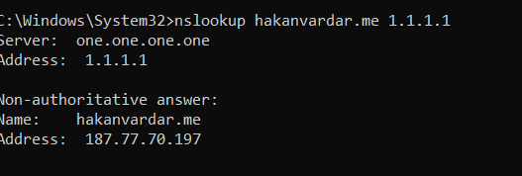

(I CROPPED THIS PHOTO, BUT THE ORIGINAL VERSION CAN BE SEEN IN THE TOP TWO IMAGES.)

Question 4:

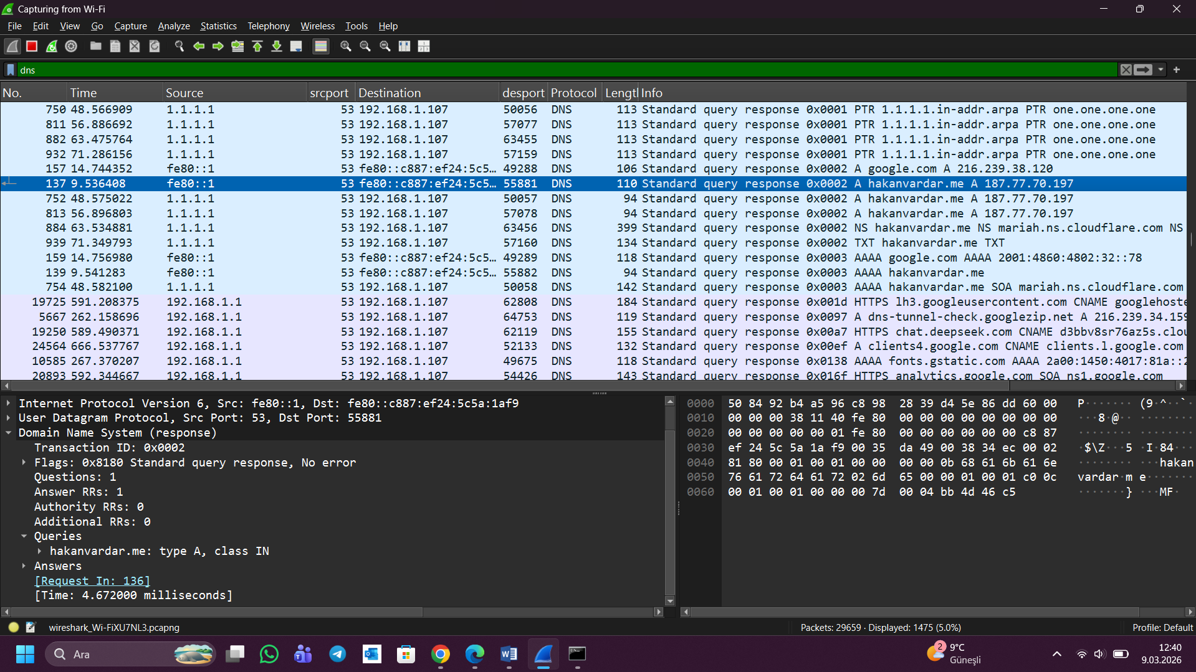

Answer:
The DNS response packet for hakanvardar.me was obtained by using Wireshark. The source IP of the DNS server is given as 1.1.1.1, and the destination IP is given as 192.168.1.107. The source port is given as 53, as it is a DNS server, and the destination port is given as 55881. The transaction ID is given as 0x0002, which is used to match the request and response. The query type is given as 'A' type, as it is used to request the IPv4 address of the domain. The response code is given as 'No error', indicating that it is a successful response. The response also contains a TTL (Time-To-Live) value which indicates how long the DNS record can be cached.
Transaction ID: 0x0002 /Query: hakanvardar.me / Query type: A / Reply code: No error /Answers: 1
Source IP: 1.1.1.1 / Destination IP: 192.168.1.107 / Source port: 53 / Destination port: 55881

Question 5:
The DNS query for the TXT record for hakanvardar.me was captured using the Wireshark tool.
The results obtained for the query show the text information that is stored within the DNS for the domain. The purpose of the TXT record is typically for domain verification, security for emails such as SPF/DKIM, etc. The results for the TXT query can be viewed within the DNS query packet. (dns.qry.type == 16)
The TXT record obtained within the DNS query results contains the text "This is a test TXT record for Wireshark lab," which can be seen within the Wireshark tool under the Answers section.
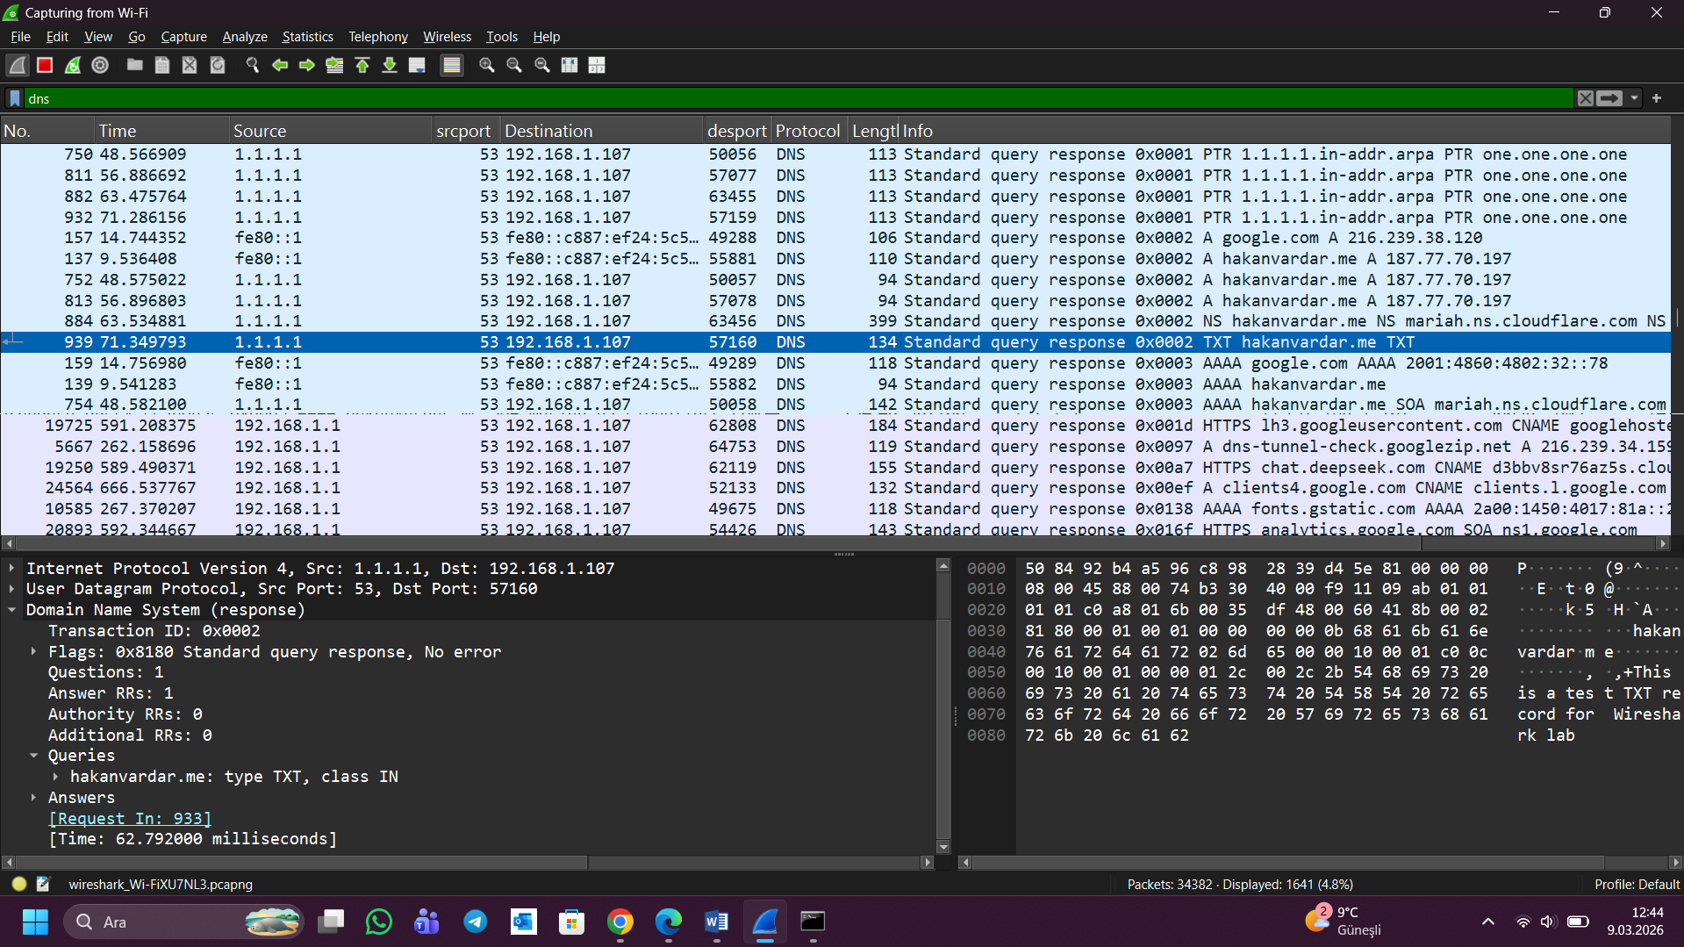

Question 6:
The DNS requests and responses were exchanged using the User Datagram Protocol. This can be identified by using the Wireshark tool and looking at the packet details, where the protocol will be identified as the User Datagram Protocol. Additionally, the source port is identified as port 53, which is the default port used by the DNS server.
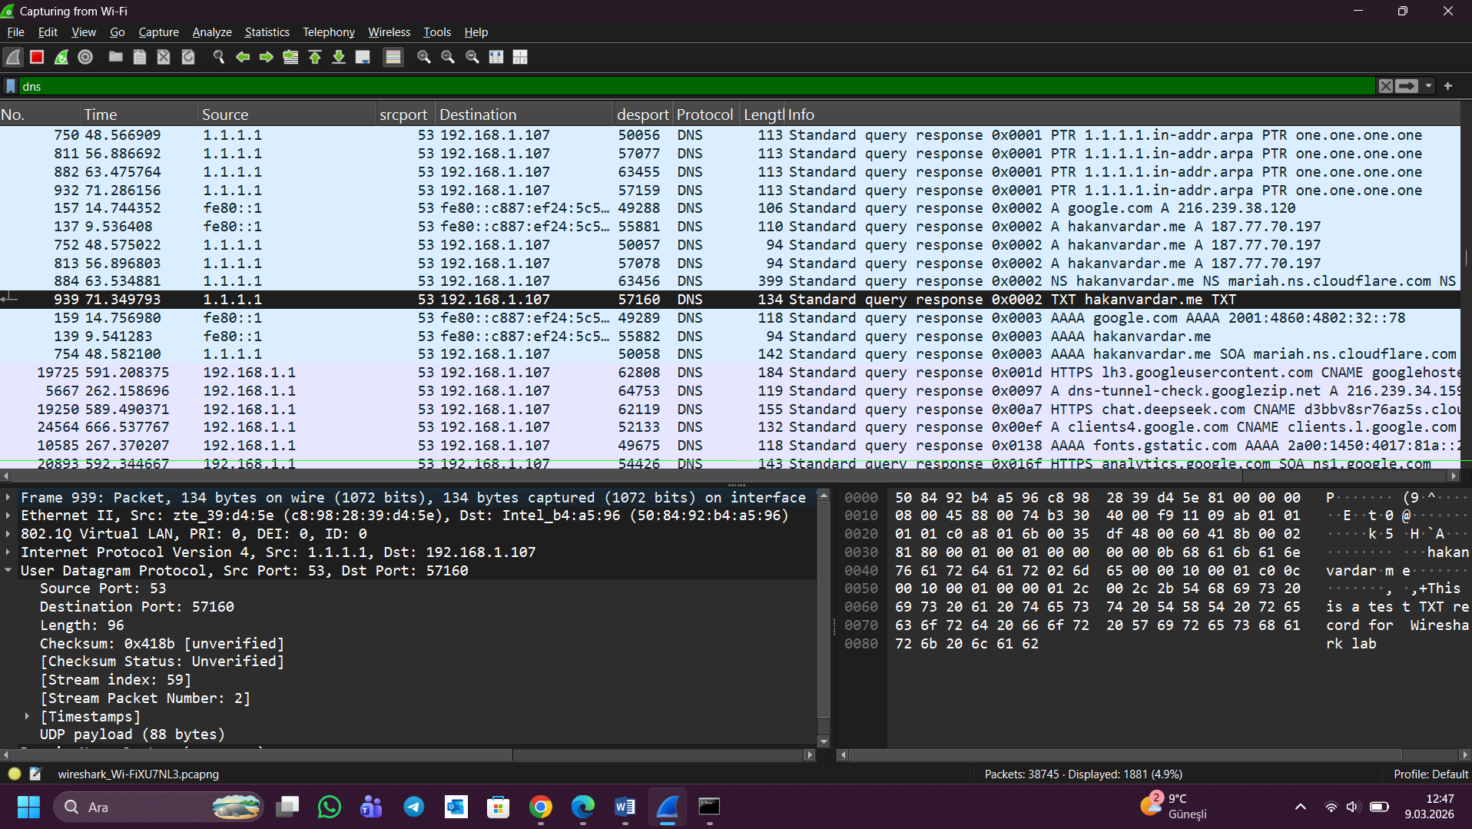

Question 7:

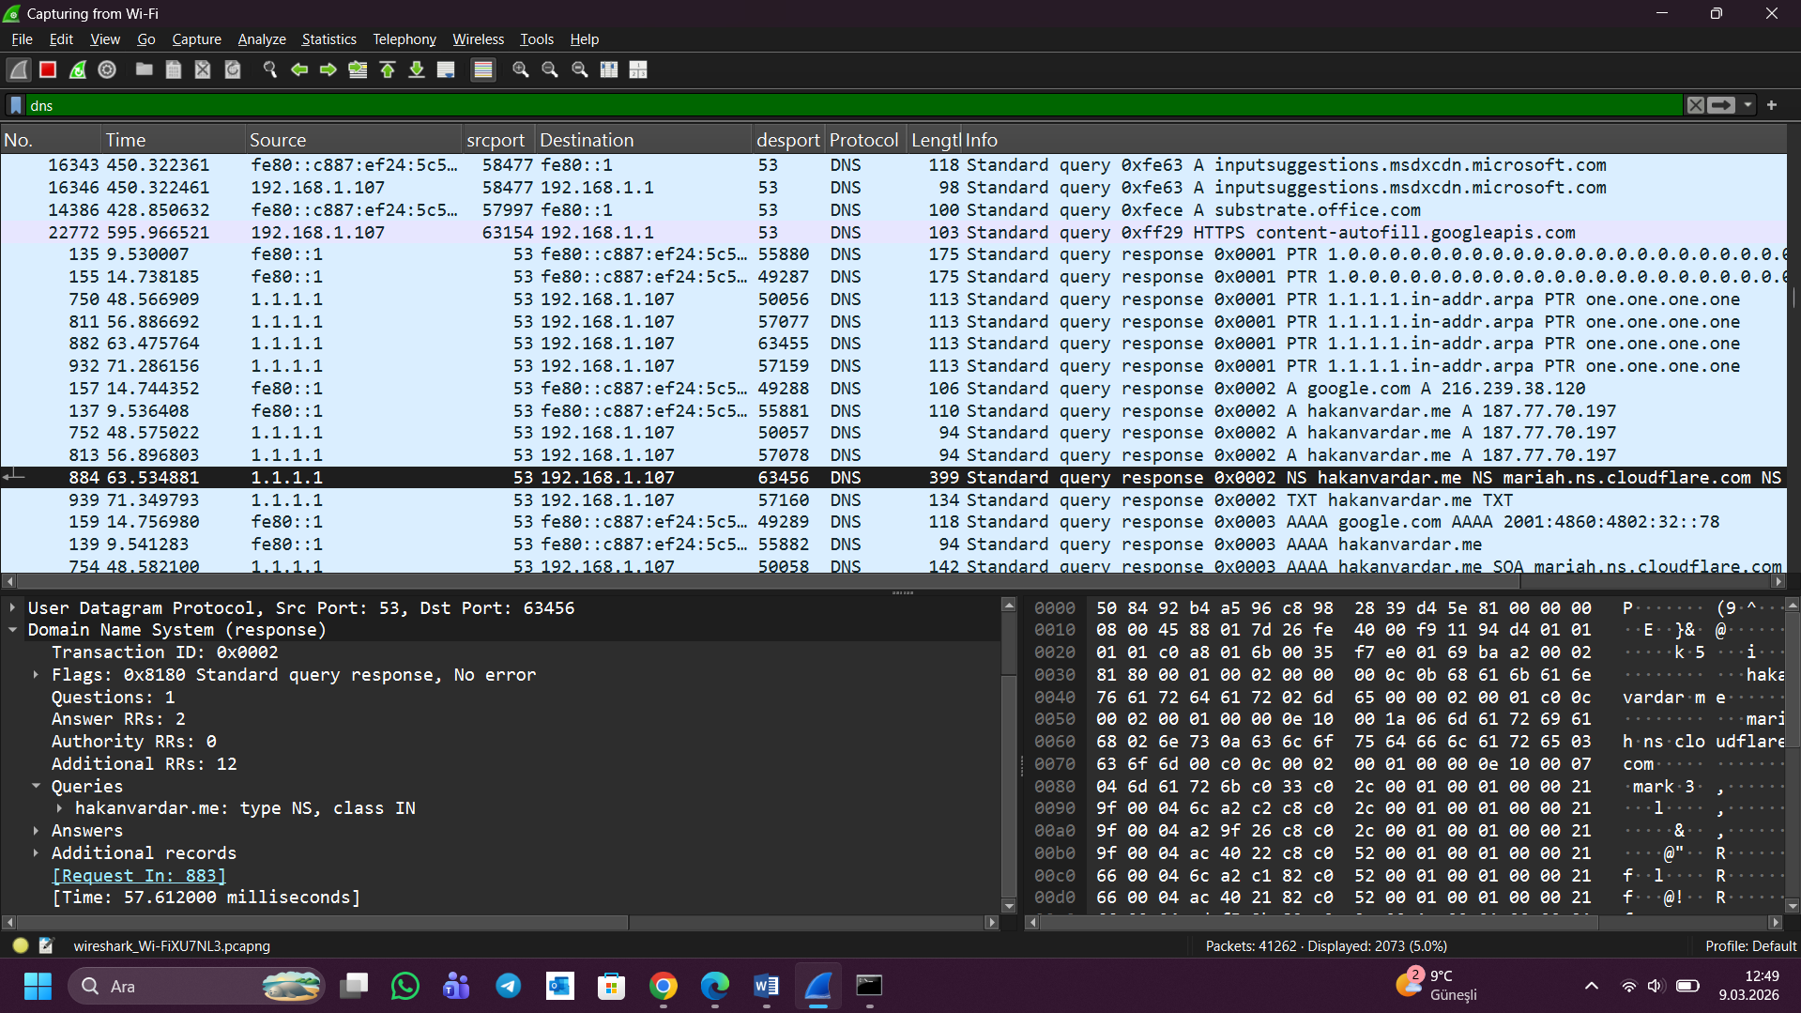

DNS query message → Questions: 1 / DNS response message → Answers: 2

The DNS query message sent for the NS record of the domain "hakanvardar.me" has 1 question. The question is to get the information about the name servers of the domain. The DNS response message received has 2 answers. The answers are the name servers that are responsible for the domain. The name servers are "mariah.ns.cloudflare.com" and "mark.ns.cloudflare.com."
Conclusion
In this lab, the DNS traffic was analyzed using Wireshark to gain a better understanding of the process of domain name resolution in a network. Different DNS queries such as A records, NS records, and TXT records were sent using the nslookup command. The packets were captured using Wireshark. By analyzing the packets, important DNS fields such as the transaction ID, query type, response code, TTL value, and source and destination ports were identified. The lab also showed that the DNS communication occurs over the UDP protocol and port 53. The response also showed the IP address and name servers for the domain name hakanvardar.me. The lab helped to associate the theory of DNS with practical knowledge.

